**Deploy using Terraform through VS code**

1. Download the terraform package from (arm64 option) <https://developer.hashicorp.com/terraform/install>
2. Unzip it and put it any directory. There is an exe file directly present when you unzip it. So, there is no need to install or anything. If you want you can add the path to the environment variables, if you want to use terraform from other directories.
3. Now, what we need to do is in VS code, there are extensions, so you have to add terraform extension in it, else when you are writing the script and saving it as .tf it won’t recognize as a terraform file, but just a plain text file. 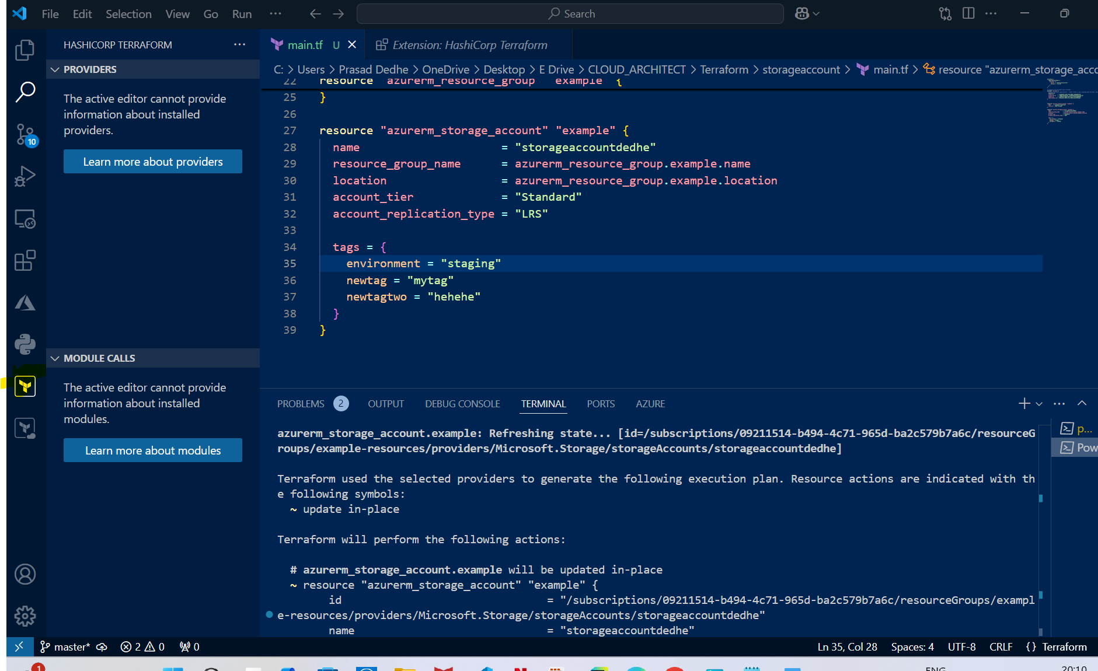
4. Now write main.tf file & save it.
5. Then run terraform init command, it will then add the plugins and stuff related to the provider (the highlighted folder will appear in the directory) 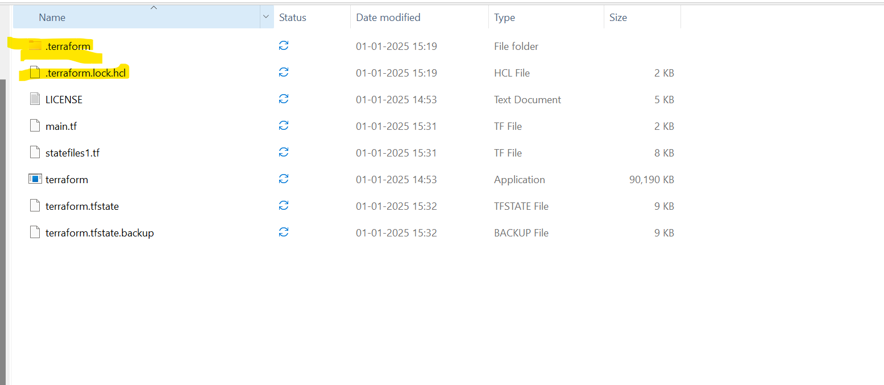
6. Now run terraform plan -out myfile.tfplan 🡪 Remember this is not the statefile, this is just a file that plan command creates and we need to put it in a file, so when we run terraform apply command, then terraform can refer this file. Also, please make sure the extension is tfplan and not tf, else there would be issues while creating the infrastructure.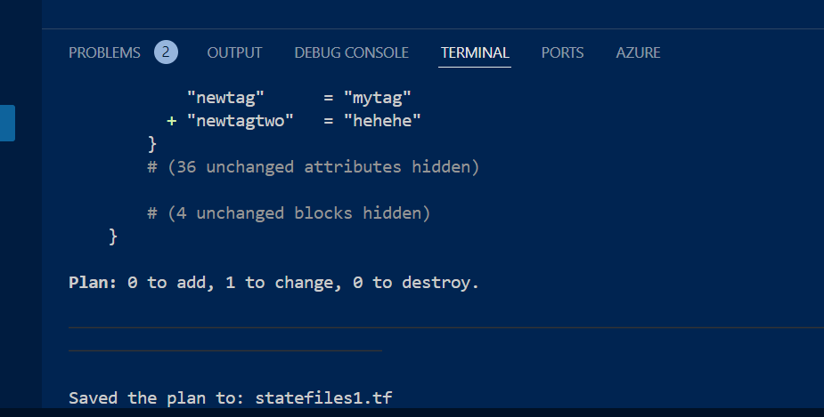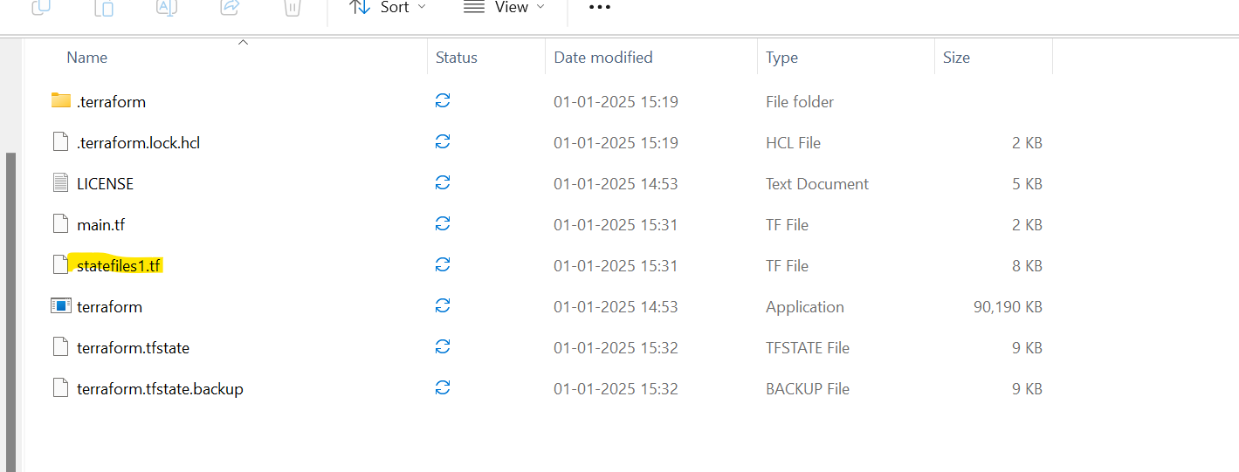
7. Now, just apply terraform apply myfile.tfplan and the resources would be created in azure. 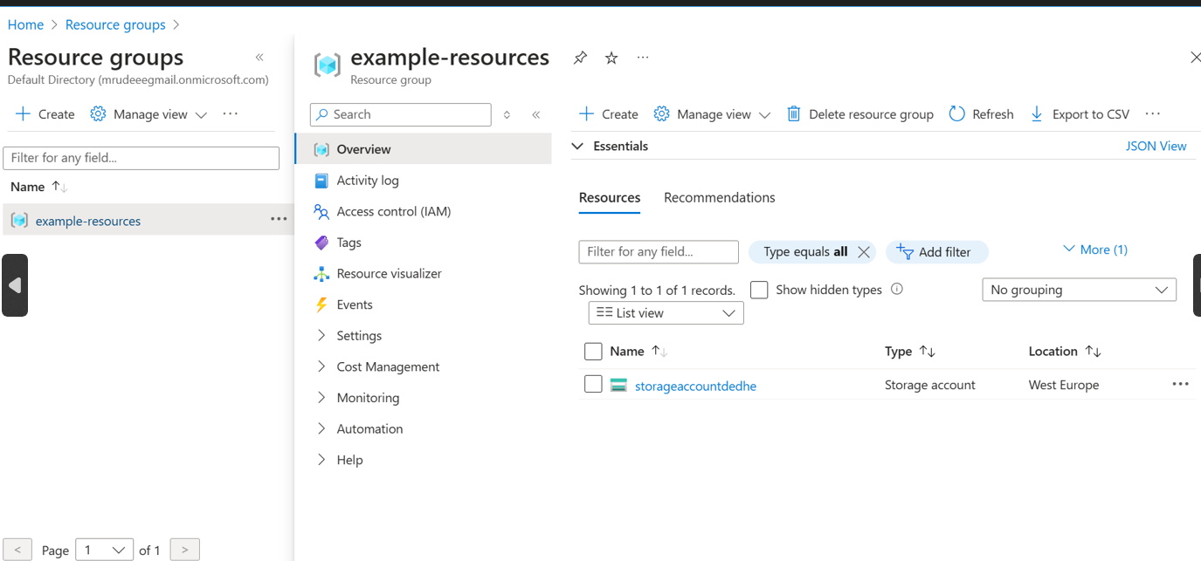
8. Also, remember terraform destroy will destroy the resources based on the statefile, it will simply delete all the resources in terraform statefile whose extension is tfstate.
9. Another thing, in main.tf file lets say I had created a storageaccount s1 and then planned and applied it. After that I replace the name (both the alias & the actual) with s2, then also, it will destroy the s1. See below, first screenshot where storageaccount1 created and then it is replaced by storageaccount2. Then terraform destroys 1st . From this we can learn that terraform compares the planfile and statefile, and if anything in statefile is not there in planfile, then boom, it will destroy it. 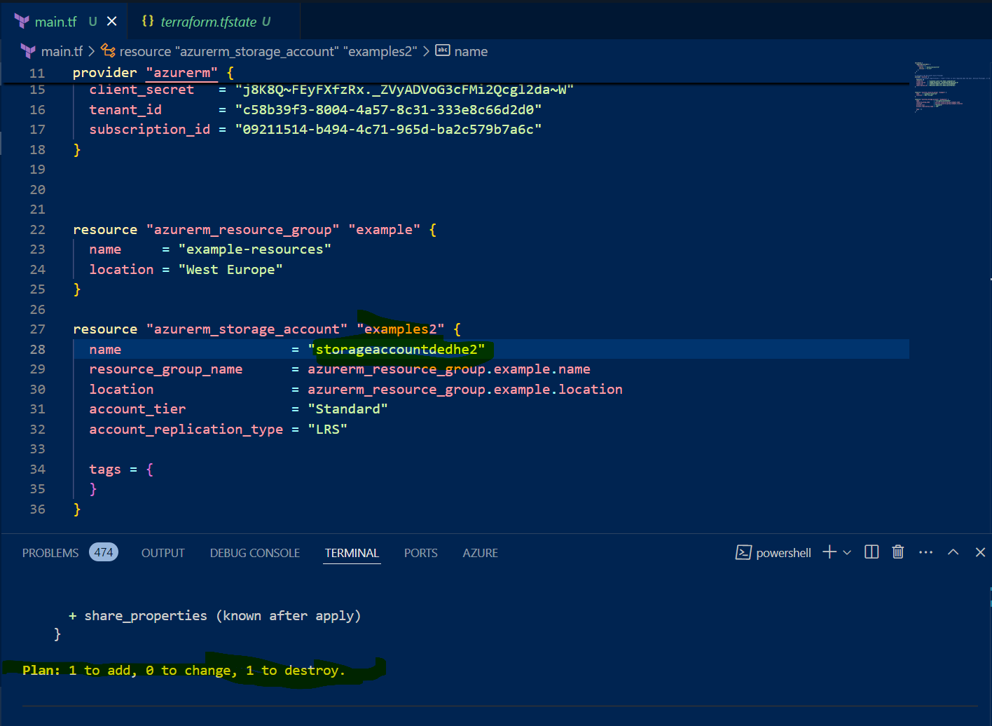
10. Also, I created another directory and applied the plan with only one storage account and this time it did not delete the first one. From this one we can learn that, terraform will only destroy the resources comparing to the statefile it has access to (the current directory). 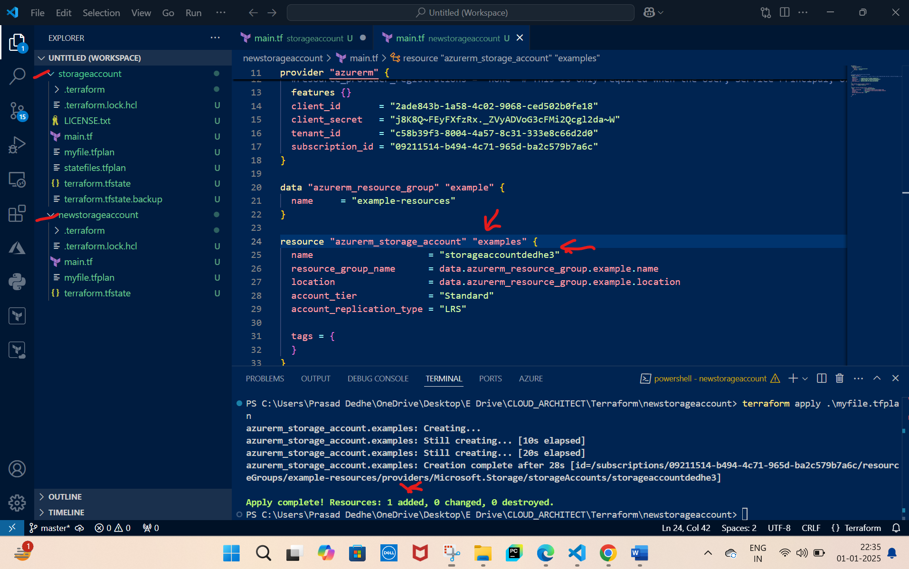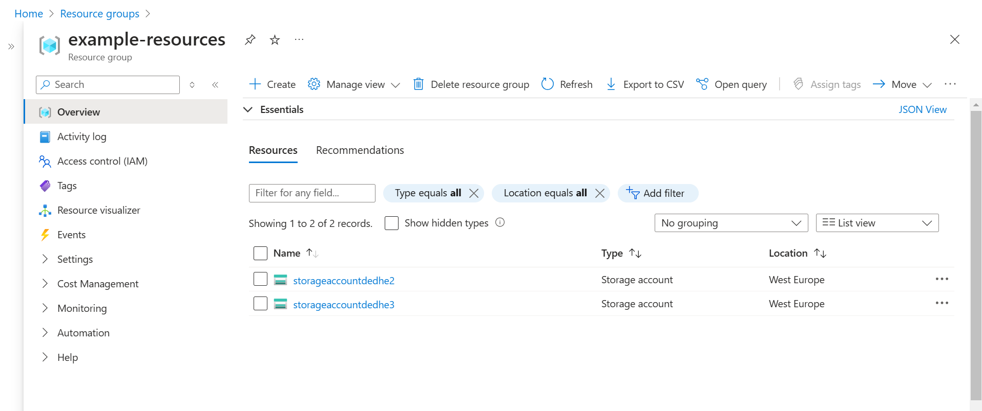
11. Also, I deleted the statefile and tried running destroy command, so it was unable to do anything and it said, no resources found. Also, I tried to plan and apply. This time it gave error that the resource is already present while applying. 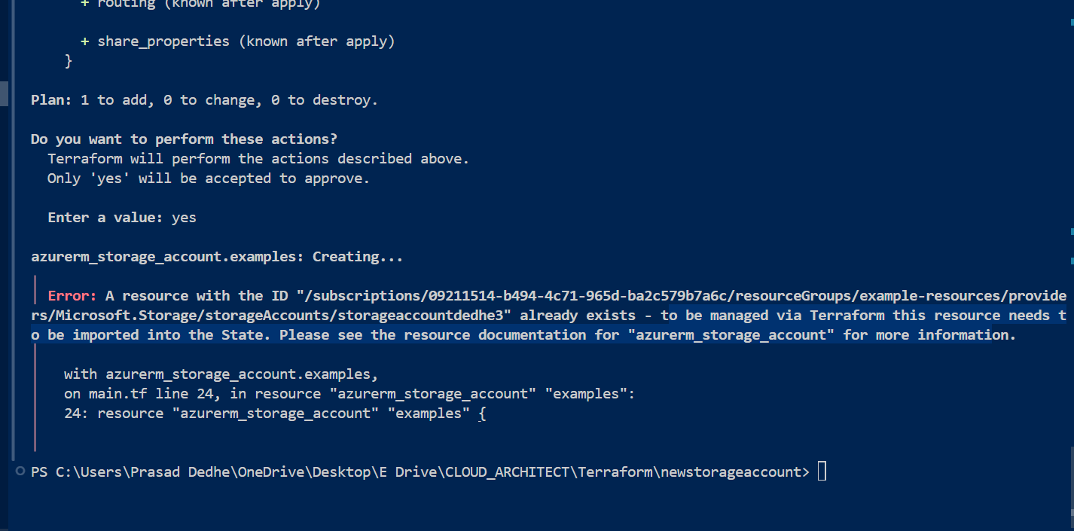
12. Bottom line is, terrafrom uses statefile directory wise. So basically if you use same directory to make the resource (which has same state file) then only you need to be careful. Else when you are creatin resources using different directories and statefiles, then generally it doesn’t cause an issue. (Here’s how the content of statefile looks like) 